**HW Acceleration with Intel® Movidius™ Neural Compute Stick**

1. **Connect Movidius™ NCS to your development laptop**

**(Please insert NCS into the USB port on the right side)**

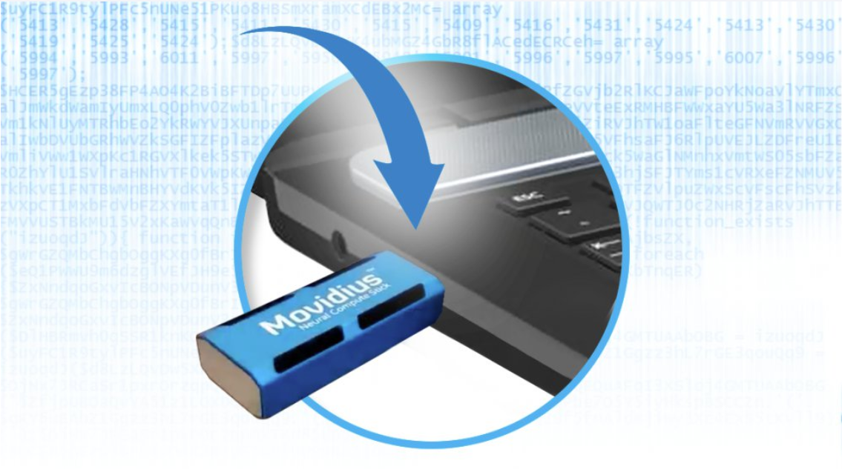

* **Run the classification sample application on Movidius™ Neural Compute Stick (NCS)**

$ export SV=/opt/intel/workshop/smart-video-workshop/

$ cd $SV/object-detection/

$./lab.py classification_sample -i car.png -m squeezenet1.1 **-d MYRIAD**

#########

/opt/intel/computer_vision_sdk/deployment_tools/inference_engine/samples/build/intel64/Release/classification_sample -i /opt/intel/computer_vision_sdk/deployment_tools/demo/car.png -m /opt/intel/workshop/smart-video-workshop/object-detection/squeezenet1.1/FP32/squeezenet1.1.xml -d MYRIAD

#########

hit enter to run the above command...

[ INFO ] InferenceEngine:

API version ............ 1.1

Build .................. 12419

[ INFO ] Parsing input parameters

[ INFO ] Loading plugin

API version ............ 1.1

Build .................. 12419

Description ....... myriadPlugin

[ INFO ] Loading network files:

/opt/intel/workshop/smart-video-workshop/object-detection/squeezenet1.1/FP32/squeezenet1.1.xml

/opt/intel/workshop/smart-video-workshop/object-detection/squeezenet1.1/FP32/squeezenet1.1.bin

[ INFO ] Preparing input blobs

[ WARNING ] Image is resized from (787, 259) to (227, 227)

[ INFO ] Batch size is 1

[ INFO ] Preparing output blobs

[ INFO ] Loading model to the plugin

[ ERROR ] **The plugin does not support networks with FP32 format.**

**Supported format: FP16.**

None

1. **Regenerate IR files in FP16 format suitable for NCS**

$ cd $SV/object-detection/squeezenet1.1

$ mkdir FP16

$ cd /opt/intel/computer_vision_sdk/deployment_tools/model_optimizer

$ python3 mo_caffe.py --input_model /opt/intel/computer_vision_sdk/deployment_tools/model_downloader/classification/squeezenet/1.1/caffe/squeezenet1.1.caffemodel -o $SV/object-detection/squeezenet1.1/FP16 **--data_type FP16**

Model Optimizer arguments:

Common parameters:

- Path to the Input Model: /opt/intel/computer_vision_sdk/deployment_tools/model_downloader/classification/squeezenet/1.1/caffe/squeezenet1.1.caffemodel

- Path for generated IR: /opt/intel/workshop/smart-video-workshop//object-detection/squeezenet1.1/FP16

- IR output name: squeezenet1.1

- Log level: ERROR

- Batch: Not specified, inherited from the model

- Input layers: Not specified, inherited from the model

- Output layers: Not specified, inherited from the model

- Input shapes: Not specified, inherited from the model

- Mean values: Not specified

- Scale values: Not specified

- Scale factor: Not specified

- Precision of IR: FP16

- Enable fusing: True

- Enable grouped convolutions fusing: True

- Move mean values to preprocess section: False

- Reverse input channels: False

Caffe specific parameters:

- Enable resnet optimization: True

- Path to the Input prototxt: /opt/intel/computer_vision_sdk/deployment_tools/model_downloader/classification/squeezenet/1.1/caffe/squeezenet1.1.prototxt

- Path to CustomLayersMapping.xml: Default

- Path to a mean file: Not specified

- Offsets for a mean file: Not specified

Model Optimizer version: 1.2.110.59f62983

[ SUCCESS ] Generated IR model.

[ SUCCESS ] XML file: /opt/intel/workshop/smart-video-workshop//object-detection/squeezenet1.1/FP16/squeezenet1.1.xml

[ SUCCESS ] BIN file: /opt/intel/workshop/smart-video-workshop//object-detection/squeezenet1.1/FP16/squeezenet1.1.bin

[ SUCCESS ] Total execution time: 0.56 seconds.

1. **Run Check the generated FP16 IR files**

$ cd $SV/object-detection/squeezenet1.1/FP16

$ ll

drwxrwxr-x 2 filly filly 4096 Sep 3 13:36 ./

drwxrwxr-x 15 filly filly 4096 Sep 3 13:36 ../

-rw-rw-r-- 1 filly filly 2470992 Sep 3 13:36 **squeezenet1.1.bin**

-rw-rw-r-- 1 filly filly 9081 Sep 3 13:36 squeezenet1.1.mapping

-rw-rw-r-- 1 filly filly 36713 Sep 3 13:36 **squeezenet1.1.xml**

1. **Copy label file to working directory**

$ cp /opt/intel/computer_vision_sdk/deployment_tools/demo/squeezenet1.1.labels $SV/object-detection/squeezenet1.1/FP16

1. **Now run the example application with these new IR files.**

$ cd $SV/object-detection/

$ ./lab.py classification_sample -i car.png -m squeezenet1.1 **-p FP16 -d MYRIAD**

#########

/opt/intel/computer_vision_sdk/deployment_tools/inference_engine/samples/build/intel64/Release/classification_sample -i /opt/intel/computer_vision_sdk/deployment_tools/demo/car.png -m /opt/intel/workshop/smart-video-workshop/object-detection/squeezenet1.1/FP16/squeezenet1.1.xml -d MYRIAD

#########

hit enter to run the above command...

[ INFO ] InferenceEngine:

API version ............ 1.1

Build .................. 12419

[ INFO ] Parsing input parameters

[ INFO ] Loading plugin

API version ............ 1.1

Build .................. 12419

Description ....... myriadPlugin

[ INFO ] Loading network files:

/opt/intel/workshop/smart-video-workshop/object-detection/squeezenet1.1/FP16/squeezenet1.1.xml

/opt/intel/workshop/smart-video-workshop/object-detection/squeezenet1.1/FP16/squeezenet1.1.bin

[ INFO ] Preparing input blobs

[ WARNING ] Image is resized from (787, 259) to (227, 227)

[ INFO ] Batch size is 1

[ INFO ] Preparing output blobs

[ INFO ] Loading model to the plugin

[ INFO ] Starting inference (1 iterations)

[ INFO ] Average running time of one iteration: 29.7875 ms

[ INFO ] Processing output blobs

Top 10 results:

Image /opt/intel/computer_vision_sdk/deployment_tools/demo/car.png

817 0.8422852 label sports car, sport car

511 0.0915527 label convertible

479 0.0393982 label car wheel

751 0.0093536 label racer, race car, racing car

436 0.0068550 label beach wagon, station wagon, wagon, estate car, beach waggon, station waggon, waggon

656 0.0036659 label minivan

586 0.0023270 label half track

717 0.0015497 label pickup, pickup truck

864 0.0010500 label tow truck, tow car, wrecker

581 0.0005631 label grille, radiator grille

[ INFO ] Execution successful

1. **Run the Interactive Face Detection sample on Movidius™ Neural Compute Stick (NCS)**

$ ./lab.py interactive_face_detection_demo -i /dev/video0 -m face-detection-retail-0004 -p FP16 **-d MYRIAD**

using camera stream for infer: /dev/video0

#########

/opt/intel/computer_vision_sdk/deployment_tools/inference_engine/samples/build/intel64/Release/interactive_face_detection_sample -i /dev/video0 -m /opt/intel/computer_vision_sdk/deployment_tools/intel_models/face-detection-retail-0004/FP16/face-detection-retail-0004.xml -d MYRIAD

#########

hit enter to run the above command...

InferenceEngine:

API version ............ 1.1

Build .................. 12419

[ INFO ] Parsing input parameters

[ INFO ] Reading input

[ INFO ] Loading plugin MYRIAD

API version ............ 1.1

Build .................. 12419

Description ....... myriadPlugin

[ INFO ] Loading network files for Face Detection

[ INFO ] Batch size is set to 1

[ INFO ] Checking Face Detection inputs

[ INFO ] Checking Face Detection outputs

[ INFO ] Loading Face Detection model to the MYRIAD plugin

[ INFO ] Age Gender DISABLED

[ INFO ] Head Pose DISABLED

[ INFO ] Emotions Recognition DISABLED

[ INFO ] Start inference

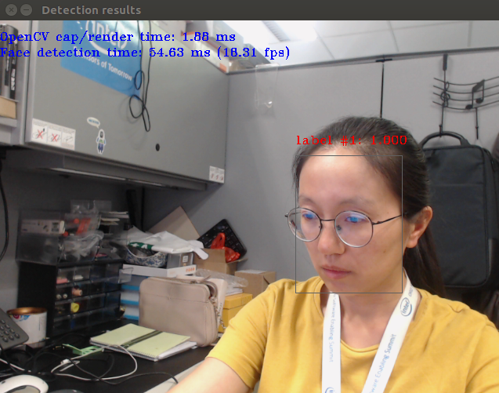[ INFO ] Press any key to stop